

|  |
| --- |
|  |
| **The Cart-Pole System** |
| Advanced Machatronics Proposal |

|  |
| --- |
| Proposed by: 1. Mona Elboughdady ID: 43-16697  2. Ahmed Zaghloul ID: 43-1  3. Bishoy Atef ID: 43-  4. John Gameel ID: 43-  5. Abdo Saad ID: 43-  Date: 10-19-2021 |

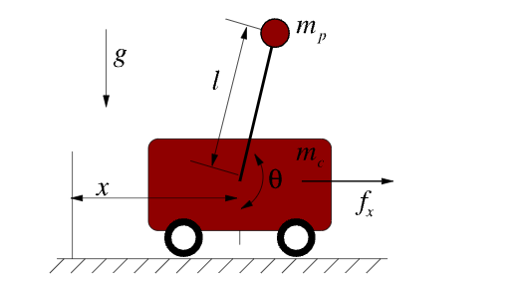

**The Cart-Pole System**

The Cart-Pole or the inverted pendulum on a cart system is an underactuated system (which has fewer number of actuators than the degrees of freedom). The system consists of an inverted pendulum mounted to motorized cart. The cart moves either forward or backward over a straight line. The goal in the Cart-Pole system is to balance a simple pendulum around its unstable equilibrium (upright direction). This is achieved by the horizontal forces on the cart.

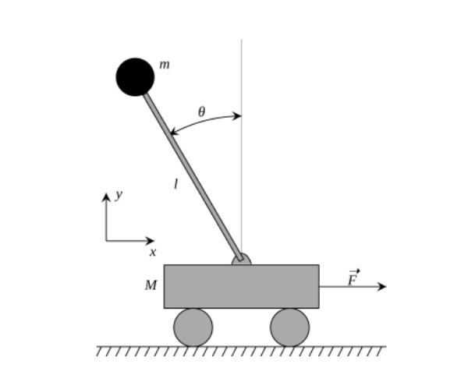

**The system inputs**

The input to the system is the forces from the motor.

**The system outputs**

The system output is the angular position of the pendulum or the pendulum angle.